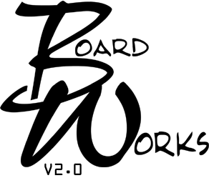

Management: Systems

How well did this workshop meet the learning objectives listed below: | Poor = 1 Excellent = 4  1 2 3 4
Discuss Public Policy systems management functions
Explore the structural foundations of organizations
Discuss organizational infrastructure
Explore provider and manager types of public organizations
Discuss community systems as an ultimate unified system

Content 1 2 3 4
Appropriate for intended audience
Consistent with stated objectives
Did any speaker attempt to sell or market products or services within the framework of this workshop? (If yes, please explain below) | Yes |  | No

Teaching Methods 1 2 3 4
Visual aids, handouts, and oral presentations clarified content
Teaching methods were appropriate for subject matter

Speaker | Poor = 1 Excellent = 4
Speaker | Knowledgeable  in content area |  |  |  | Content consistent  with objectives |  |  |  | Clarified content response to question
 | 1 | 2 | 3 | 4 | 1 | 2 | 3 | 4 | 1 | 2 | 3 | 4
Christopher Pinter

Additional Comments:

Request for BoardWorks Credit: In order to receive BoardWorks credit for this course you must complete the above evaluation, fill-in the information below and return this form to Community Mental Health Association, 507 South Grand Ave., Lansing, Michigan 48933, or you can email the form to Monique Francis at mfrancis@cmham.org. There is no longer a fee to process evaluations.

_______________________________________________ ________________________________________________
Signature Name (print)

_______________________________________________
CMHSP (REQUIRED)

