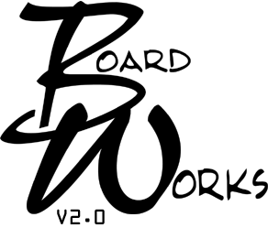

Leadership – Participatory Governance and Ethical Implications

How well did this workshop meet the learning objectives listed below: | Poor = 1 Excellent = 4  1 2 3 4
Explore ethical issues of honor, loyalty, integrity and conflicts of interest.
Commitment to promotion/protection of rights/responsibilities of intended beneficiaries.
Commitment to the values and intent of public policy and the public system.
Responsibility for remaining knowledgeable, informed and competent.

Content 1 2 3 4
Appropriate for intended audience
Consistent with stated objectives
Did any speaker attempt to sell or market products or services within the framework of this workshop? (If yes, please explain below) | Yes |  | No

Teaching Methods 1 2 3 4
Visual aids, handouts, and oral presentations clarified content
Teaching methods were appropriate for subject matter

Speaker | Poor = 1 Excellent = 4
Speaker | Knowledgeable  in content area |  |  |  | Content consistent  with objectives |  |  |  | Clarified content response to question
 | 1 | 2 | 3 | 4 | 1 | 2 | 3 | 4 | 1 | 2 | 3 | 4
Raul Gonzalez
Lois Shulman

Additional Comments:

Request for BoardWorks Credit: In order to receive BoardWorks credit for this course you must complete the above evaluation, fill-in the information below and return this form to Community Mental Health Association, 507 South Grand Ave., Lansing, Michigan 48933, or you can email the form to Monique Francis at mfrancis@cmham.org. There is no longer a fee to process evaluations.

_______________________________________________ ________________________________________________
Signature Name (print)

_______________________________________________
CMHSP (REQUIRED)

